**Bug bounty programs in blockchain: -**

1. Two websites where we can find the projects to find the bugs on them
2. <https://immunefi.com/>
3. <https://code4rena.com/>
4. We can see on etherscan for contracts to find bug

**Wallets: -**

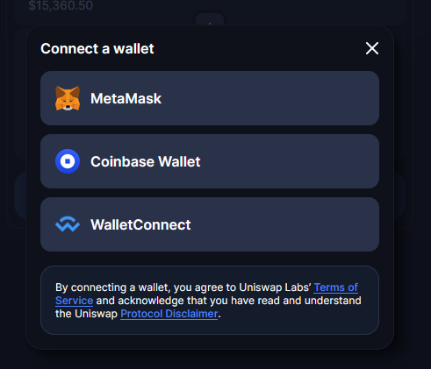

[**ERC**](https://www.youtube.com/watch?v=g3IKJnInY4k) **has different standard to create your own crypto currency/ICO.**

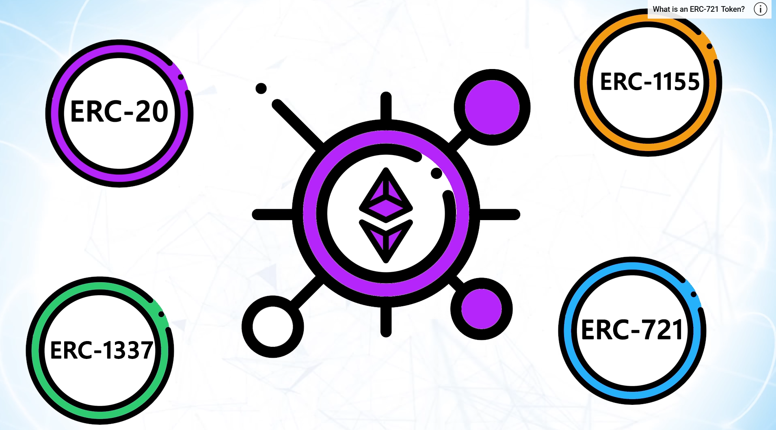

this is a standard used to make your own coin using smart contract on Ethereum, in this tech you create your own token using eth and these coins can be used a normal crypto currency.

Blockchain explorer shows the data of blockchain on website, you can run the node and get the data of blockchain about meem poll transactions and has rates and then show them on our website.

**Websties for jobs : -**

**<https://remote3.co/>**

[**https://web3.career/**](https://web3.career/)

[**https://cryptocurrencyjobs.co/web3/**](https://cryptocurrencyjobs.co/web3/)